ecksbot Electronics Instructions

# Step 1 – Part and Tool Checklist

The first step in attaching the electronic parts, table and hot end to your ecksbot is making sure that you have all of your parts, and the necessary tools.

(Note: need to retake the bed picture with the required nuts and washers as well as the attached wire. Also need a picture of the endstop holders with bolts, nuts, and allen wrench and check the bolt lengths)

|  |  |  |  |
| --- | --- | --- | --- |
| **chk** | **Components** | **chk** | **Tools** |
|  | 1 x Power Supply |  | 1 x Slot Screw Driver |
|  | 1 x Ramps 1.4 complete ecksbot wired |  | 1 x Scissors |
|  | 3 x endstops numbered (2,4,6) |  | 1 x 4mm Hex wrench |
|  | 1 x 12 position terminal block |  | 1 x 3mm Hex wrench |
|  | 1 x 4 position terminal block |  | 1 x 4mm wrench |
|  | 1 x 8 position terminal block |  | 1 x Needle Nose Pliers (optional) |
|  | 2 x 6 position terminal block |  |  |
|  | 3 x printed endstop holders |  |  |
|  | 30 x zip ties |  |  |
|  | 1 x bed controller |  |  |
|  | 1 x length of spiral wrap |  |  |
|  | 1 x 40mm fan |  |  |
|  | 1 x Eckertech all metal hot-end |  |  |
|  | 1 x Eckertech bed heater |  |  |
|  | 14 x 4mm nuts |  |  |
|  | 4 x 4mm bolts 10mm long |  |  |
|  | 10 x 4mm washers |  |  |
|  | 3 x 3mm nylock nuts |  |  |
|  | 3 x 3mm bolts 16mm long |  |  |

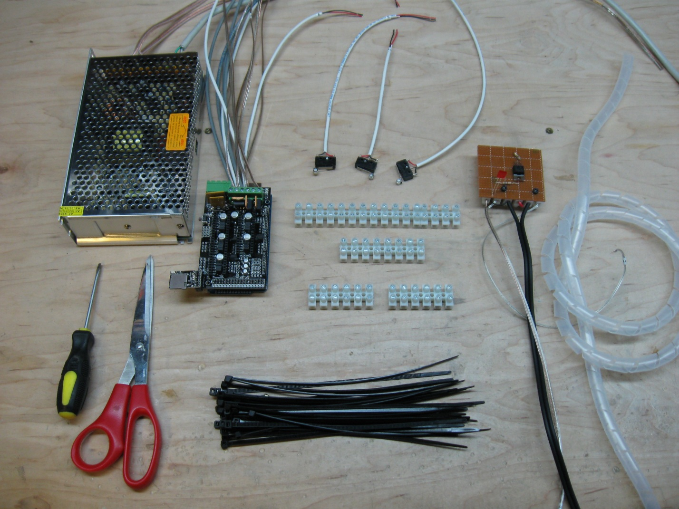

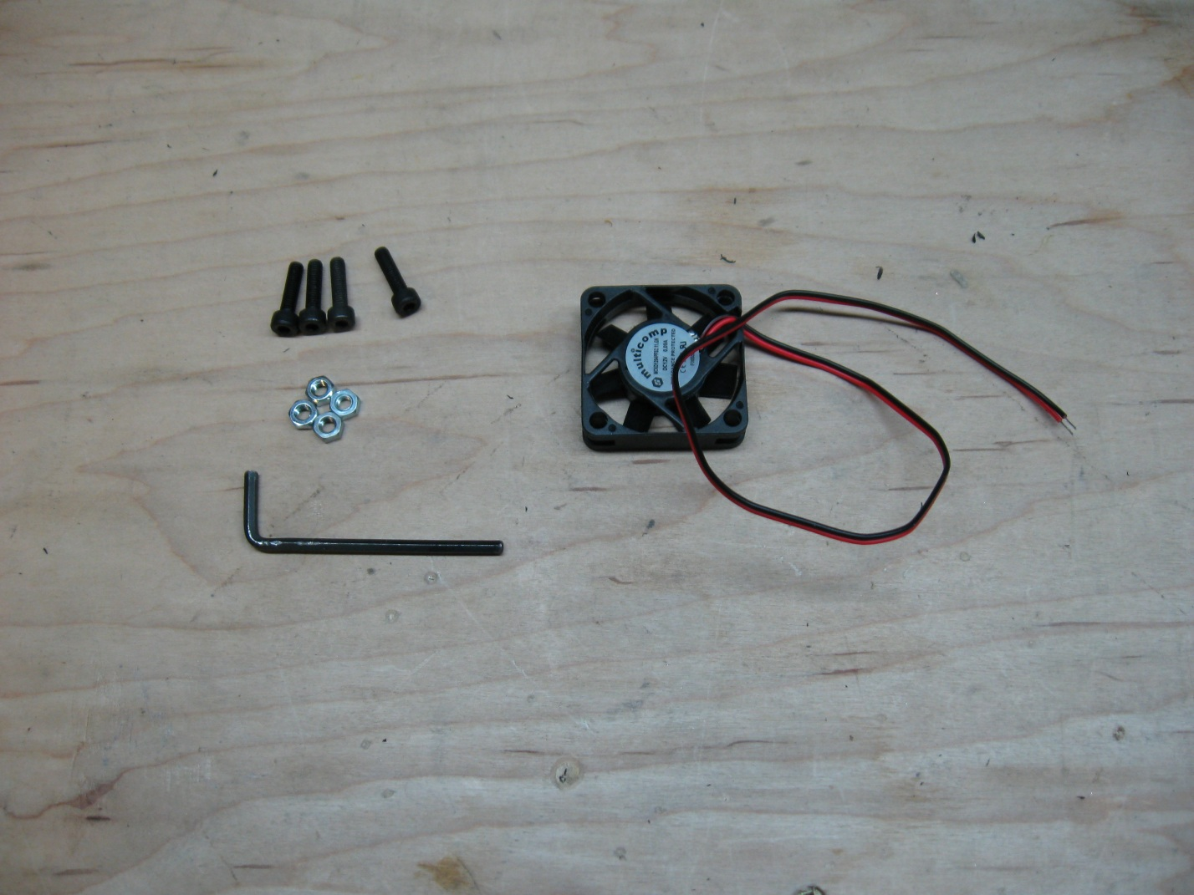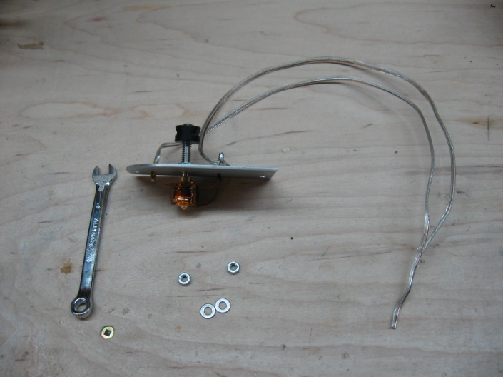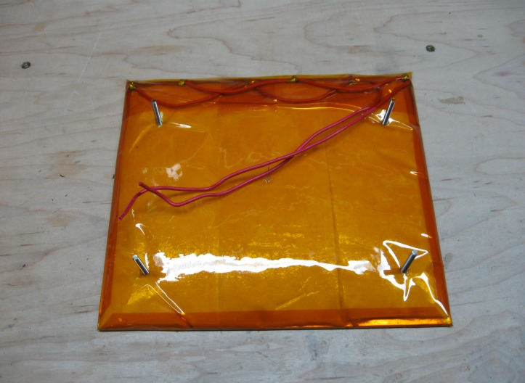

# Step 2 – Attaching Terminal Blocks

Once you have gathered all the required tools and parts, and have a nice flat area to work on, we start the electrical connections by attaching all the terminal blocks. All of the electrical connections for your ecksbot will be made using the provided terminal blocks, no need for any soldering. For this step you’ll need the scissors, terminal blocks and 10 zip ties.

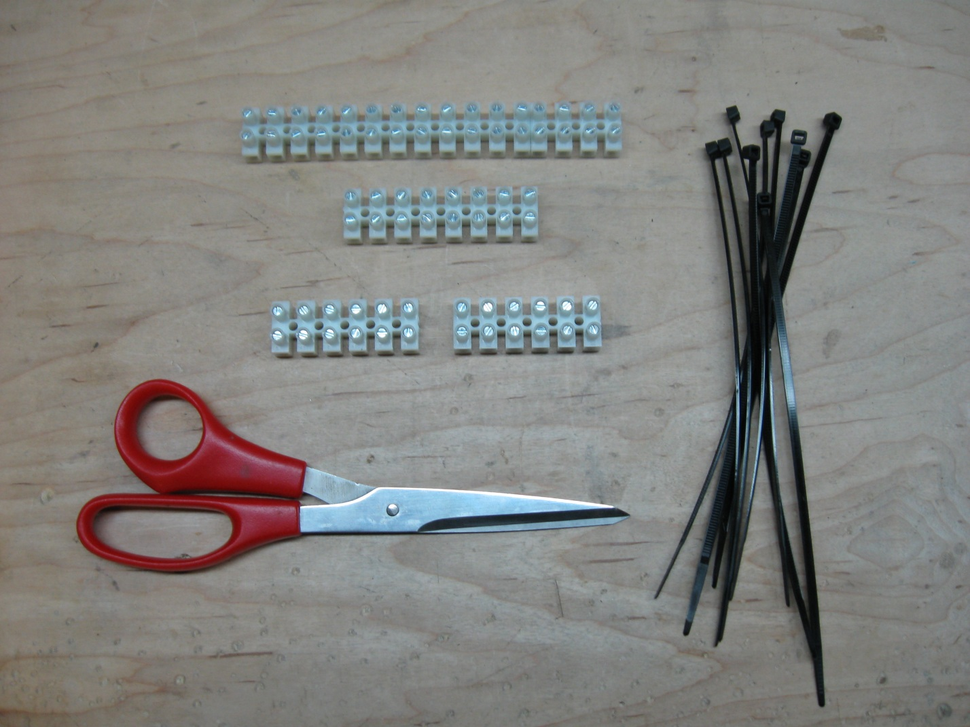

Start by placing your machine as I have in the following picture so that we can attach the X terminal block on the right side.

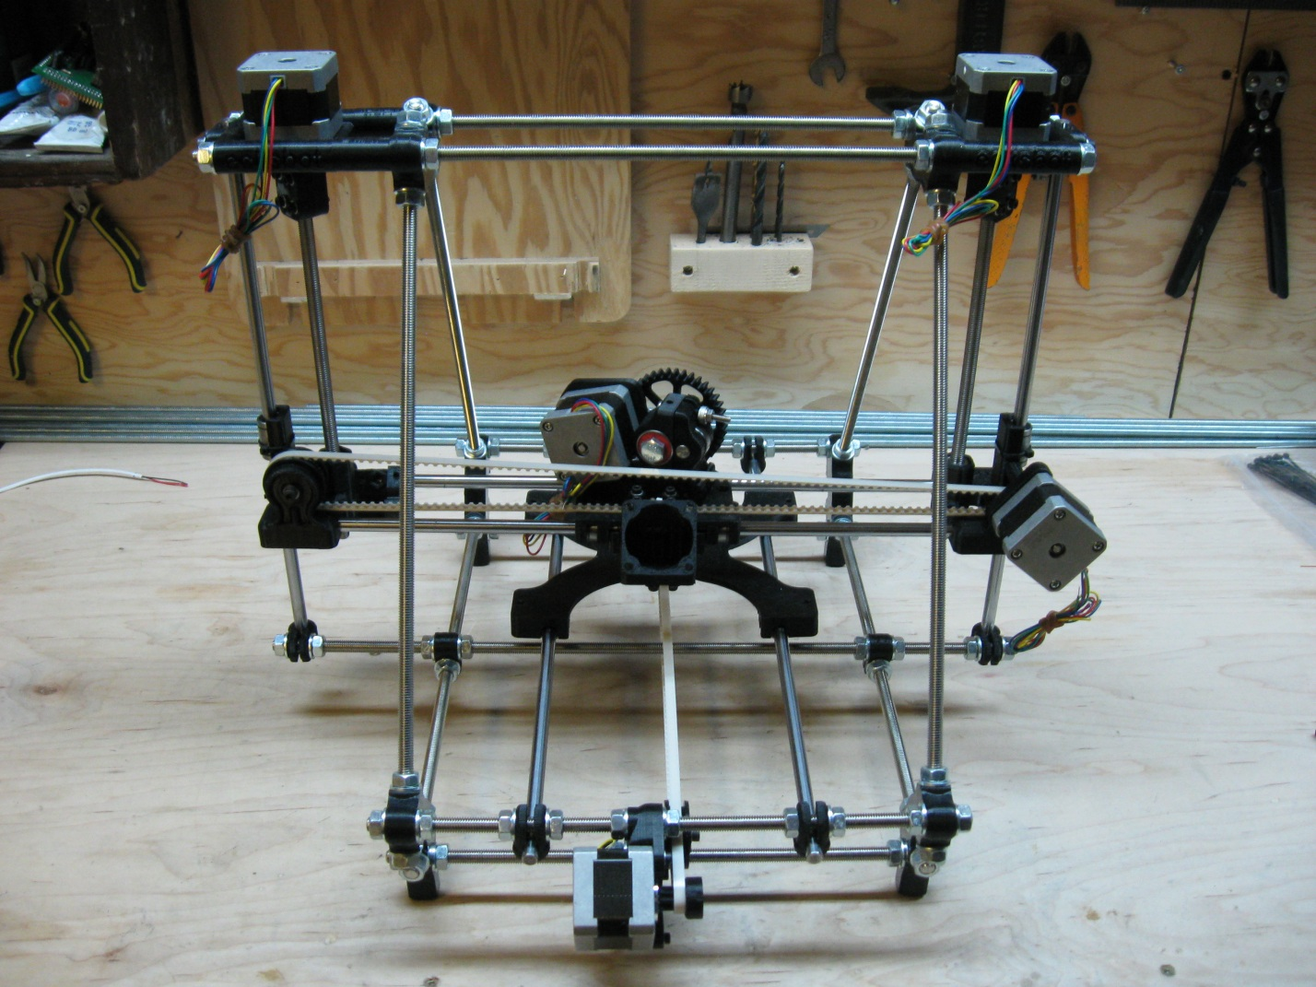

The X terminal block is one of the 6 position blocks and is placed on the right vertex rod as seen in the following picture.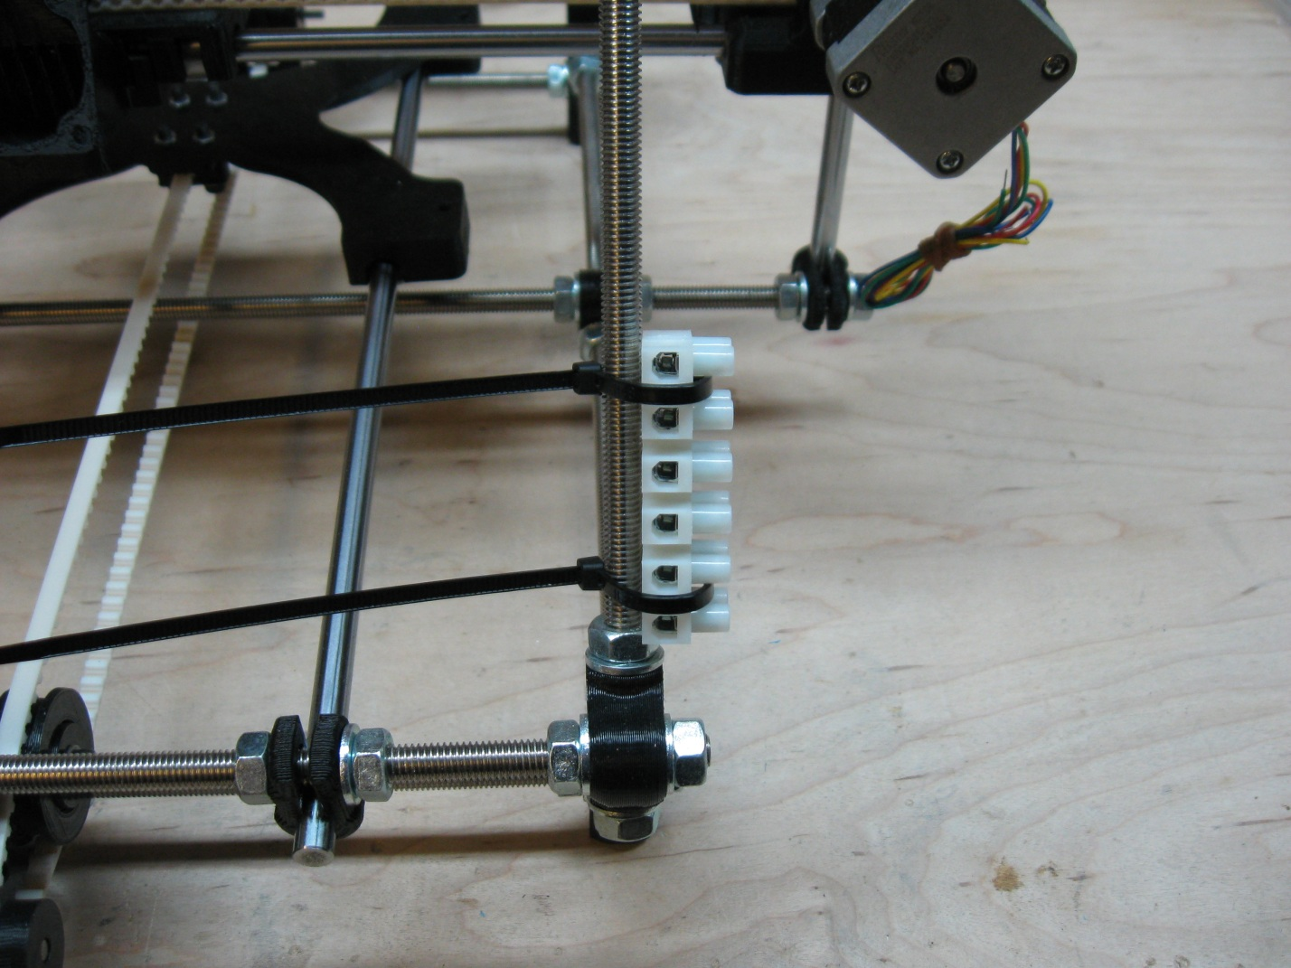

Loosely attach the block using 2 zip ties and adjust the block so that it is just sitting on the bottom 8mm nut and so that the zip ties are parallel to the table surface. Also be sure that the zip ties are placed so that when you tighten them, they will slot between the terminal block wire positions. Once you are happy with the alignment, tighten the zip ties are tight as you can, making sure that the zip ties slot in between the terminal positions tightly. See the next photo for what the final product should look like.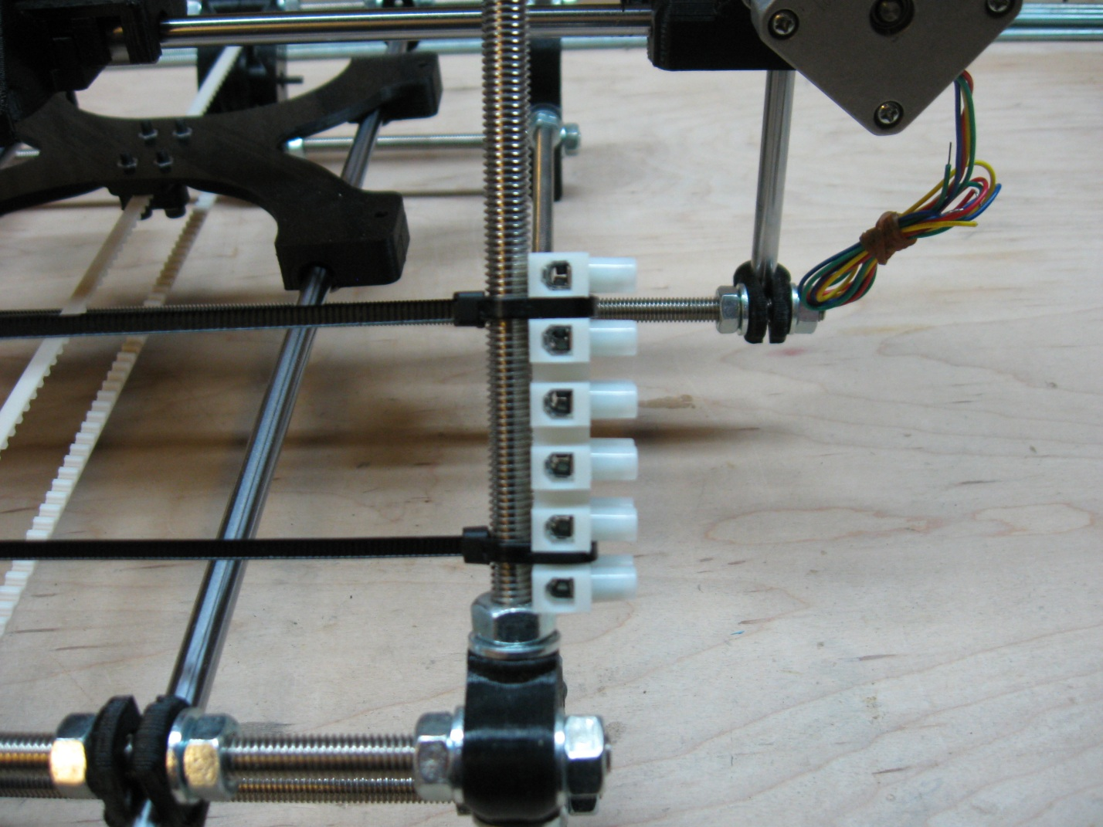

Once you have the zip ties tightened as much as you can, clip them off and you have your first terminal block attached in its final position.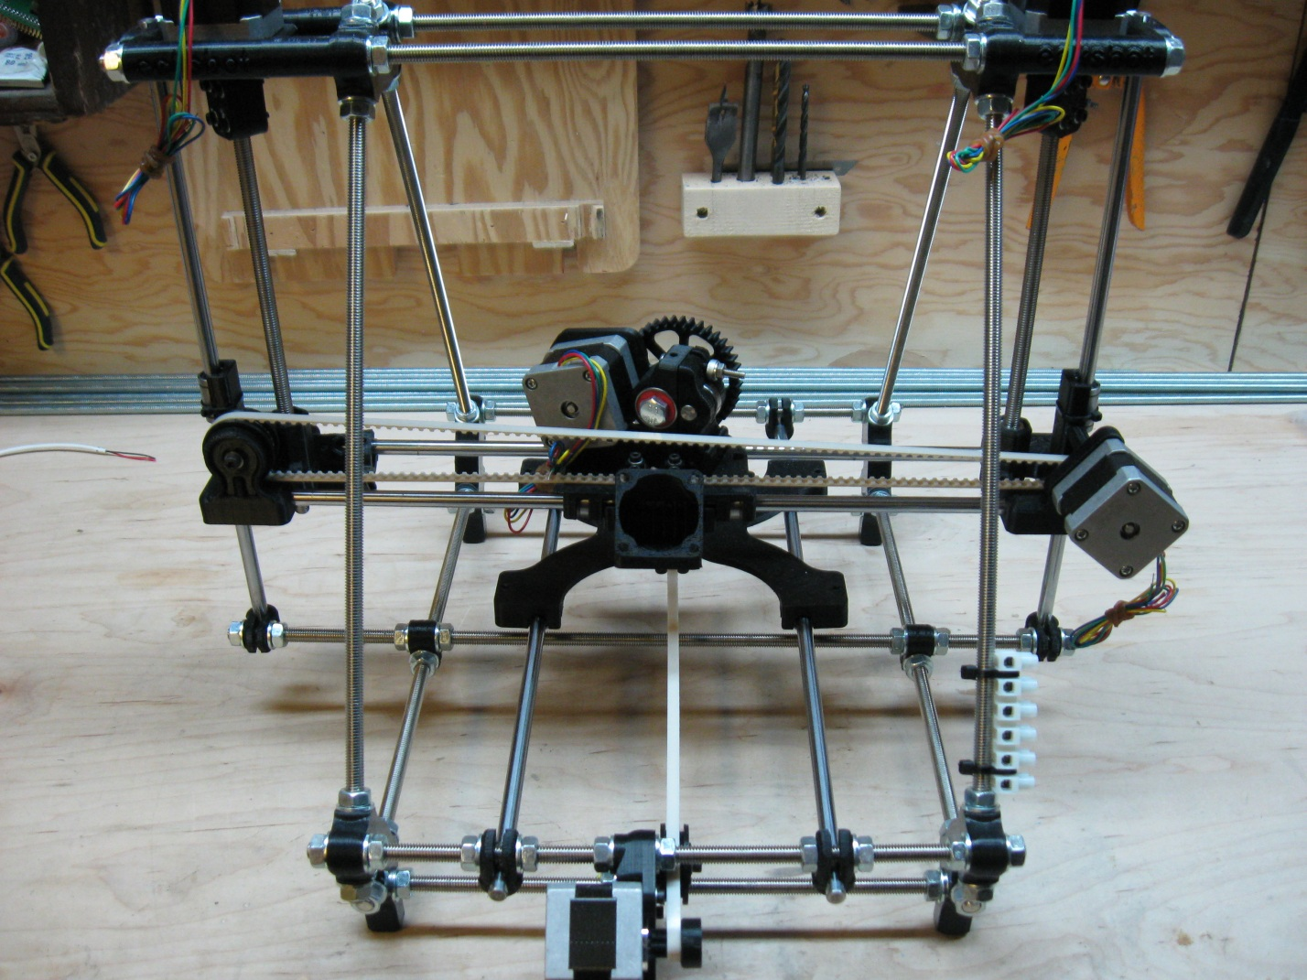

Next we will attach the largest set of terminal blocks that act as the connections for the z motors, extruder motor, and hot-end, thermistor and extruder fan. This terminal block is formed using the 12 position block and the 4 position block. The blocks will be attached to the top threaded rod, closest to you when looking at the printer from the back. Be sure that the 4 position block is on the right hand side and butted up firmly to the 12 position block. The following picture shows where to position the block and the zip ties.

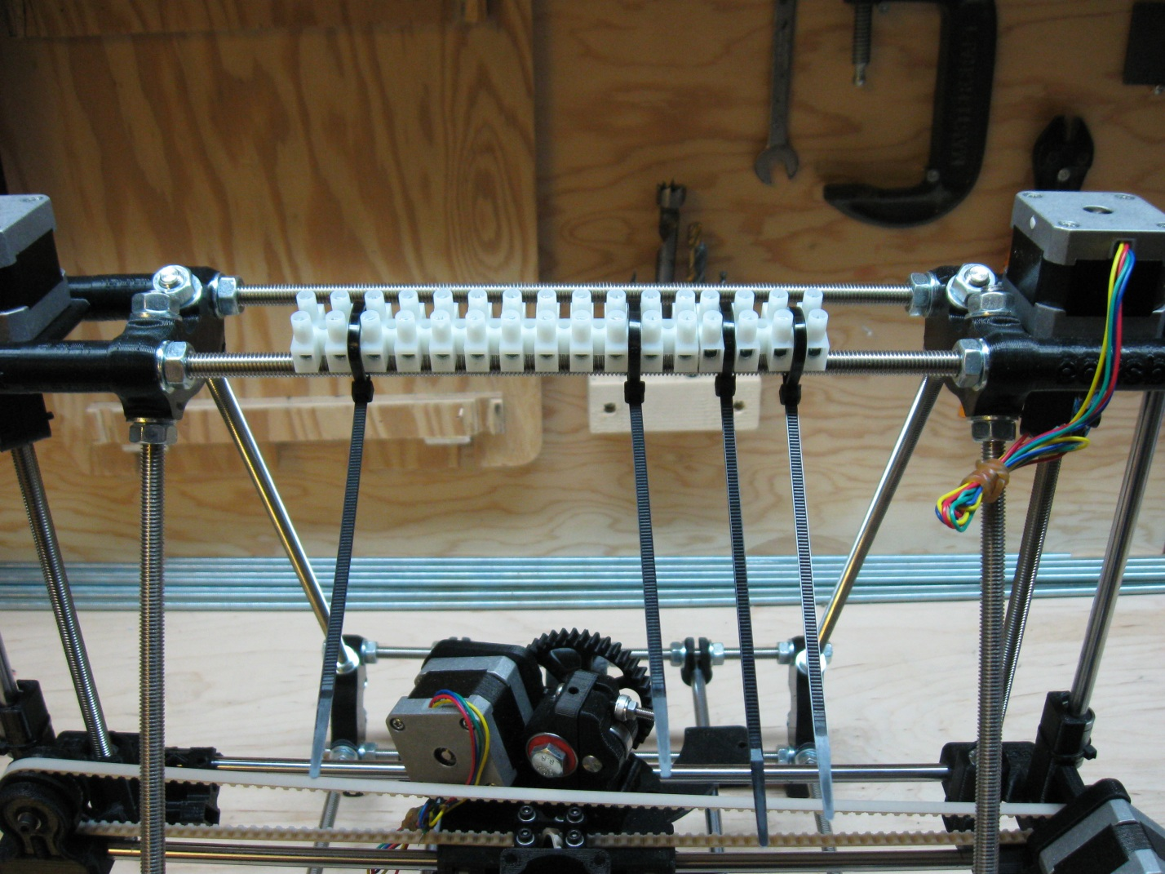

Once you are happy with the positioning of the terminal blocks and the placement of the zip ties, tighten the zip ties as tight as you can and then clip the ends off.

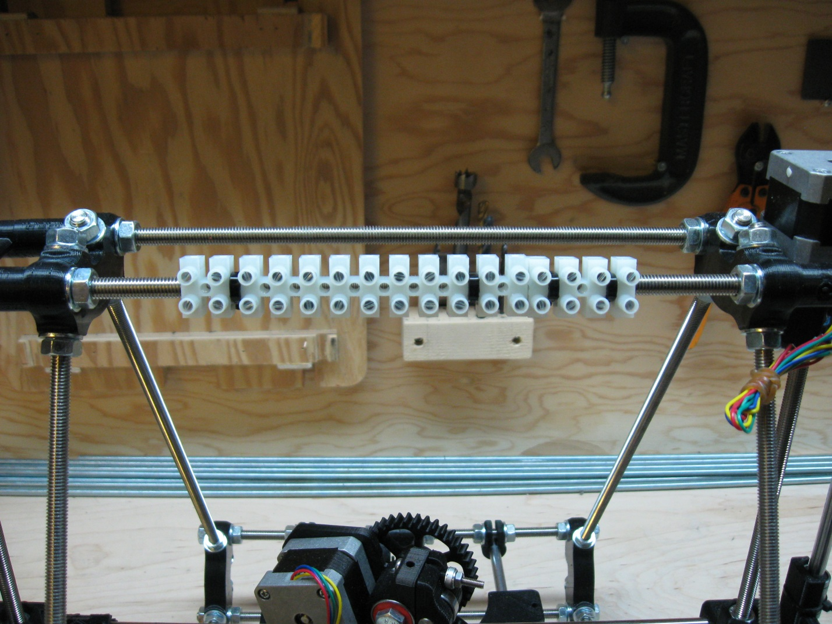

We now tip the printer onto its front so that we can access the bottom Y-Motor threaded rod for placement of the Y-Motor terminal block.

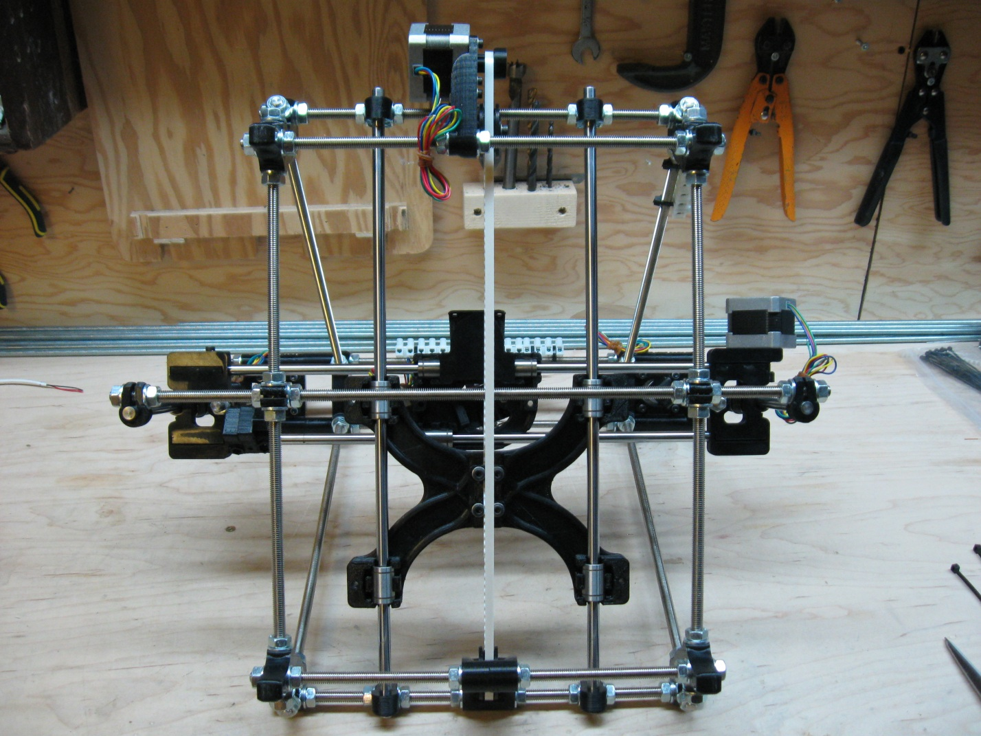

The Y-Motor terminal block is the second of the 6 position terminal blocks, and is placed to the right of the Y-Motor mount when viewed from the position of the printer in the above picture. The block is placed on the bottom threaded rod so that it is out of the way when the printer is right side up. Place the block midway between the Y-Motor mount and the right hand vertex as pictured below. Once you are happy with the placement and position of the zip ties, tighten the zip ties as tight as you can and then clip the ends off using the scissors.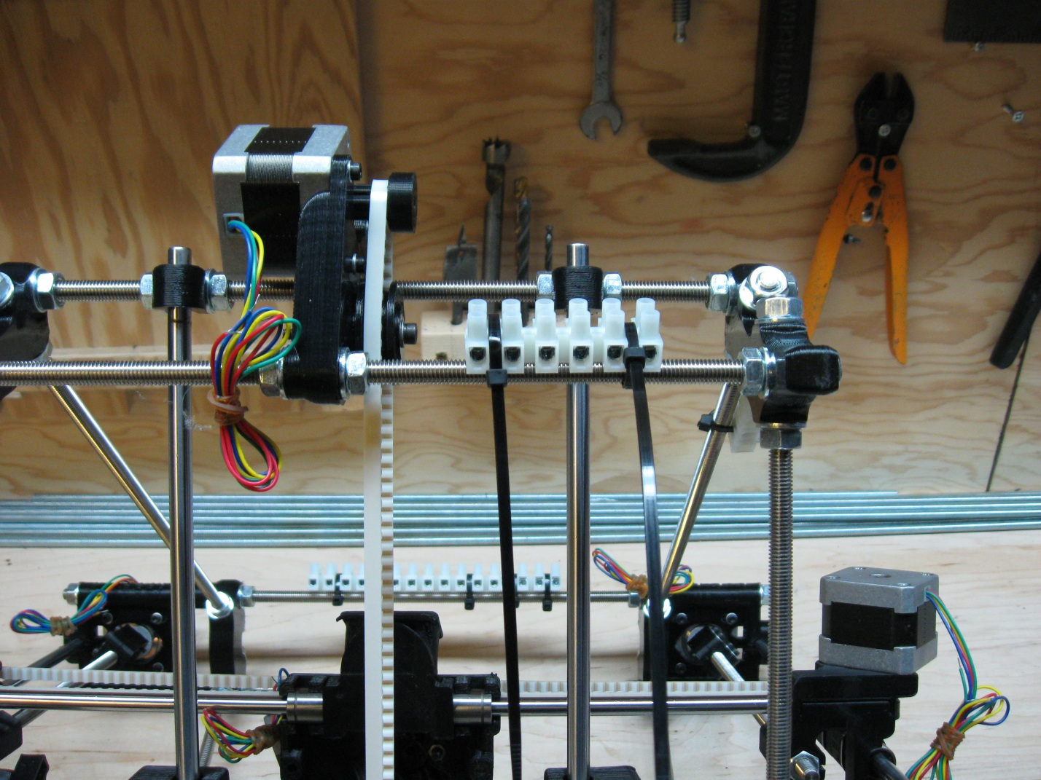

We then turn the machine 90 degrees counter clock wise to position the final terminal block as pictured in the following photo.

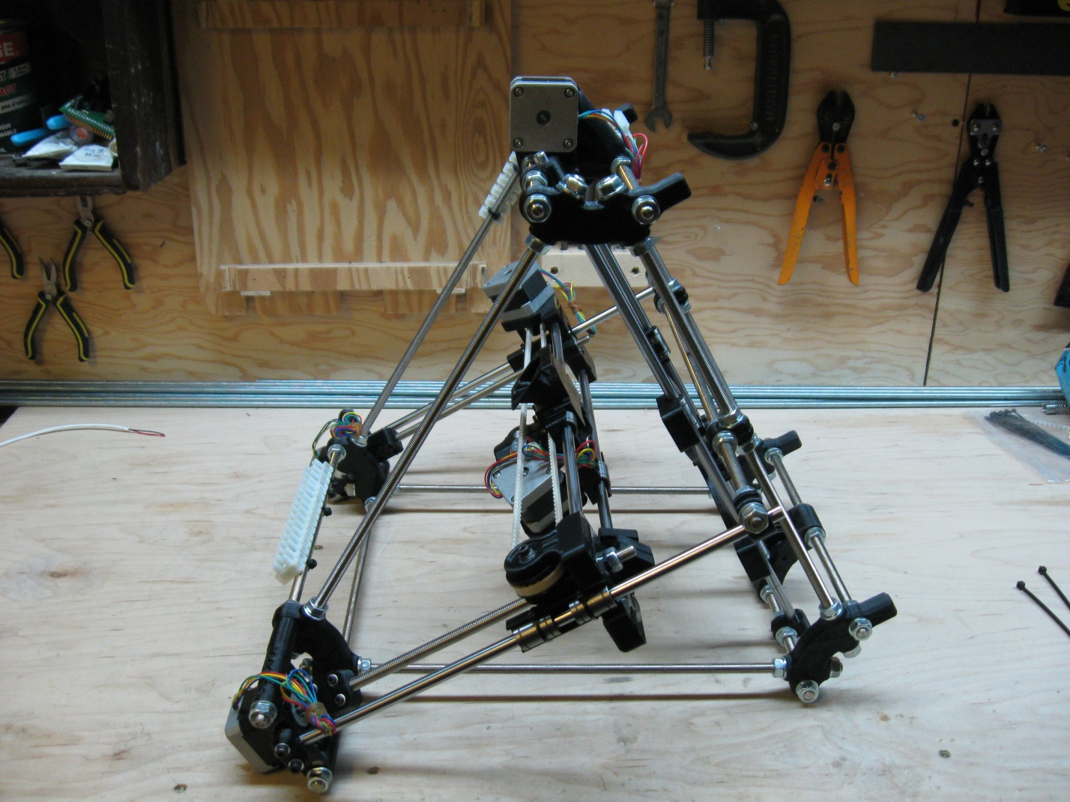

This terminal block is the 8 position block used to connect the heated bed and the Z-Endstop. This block is placed on the bottom vertex rod against the back vertex nut as shown in the following picture.

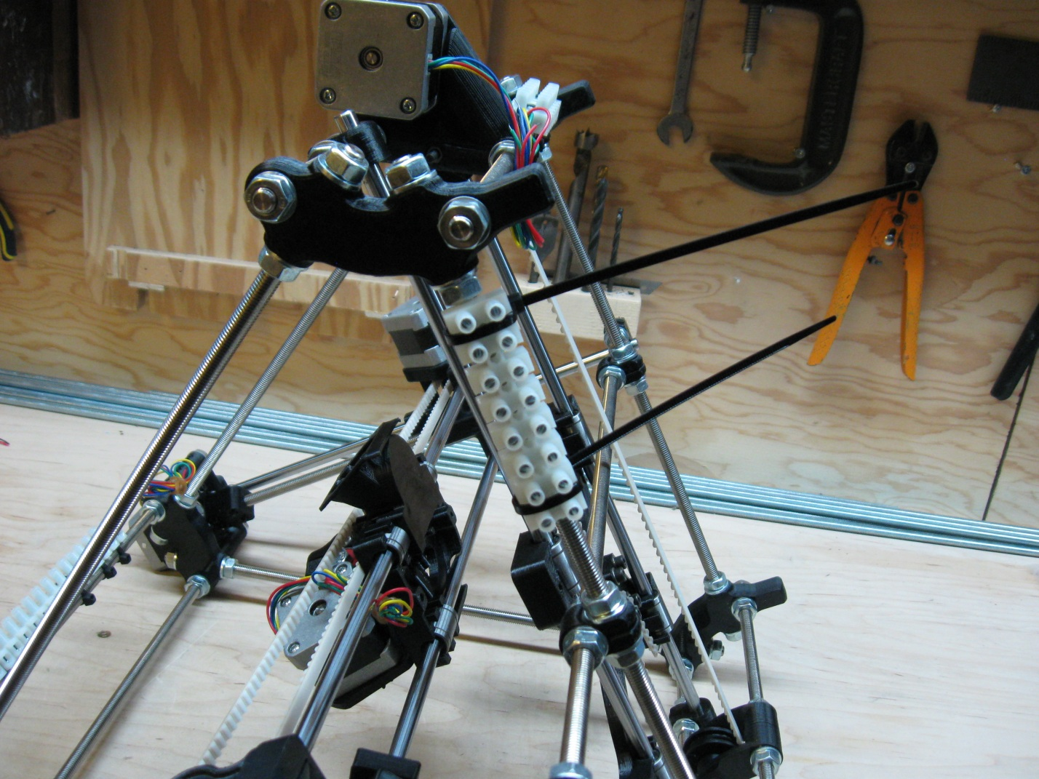

Once you are happy with the blocks placement and the placement of the zip ties, again tighten them as tight as you can and clip the ends.

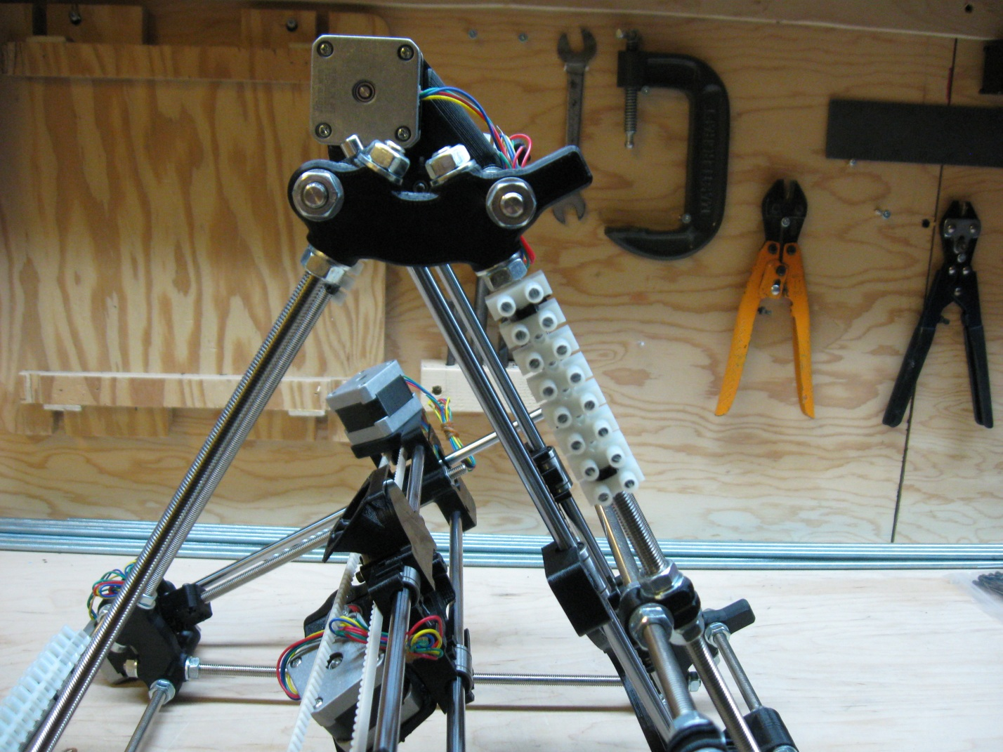

This completes Step 2 now that all your terminal blocks are now placed correctly and secured tightly.

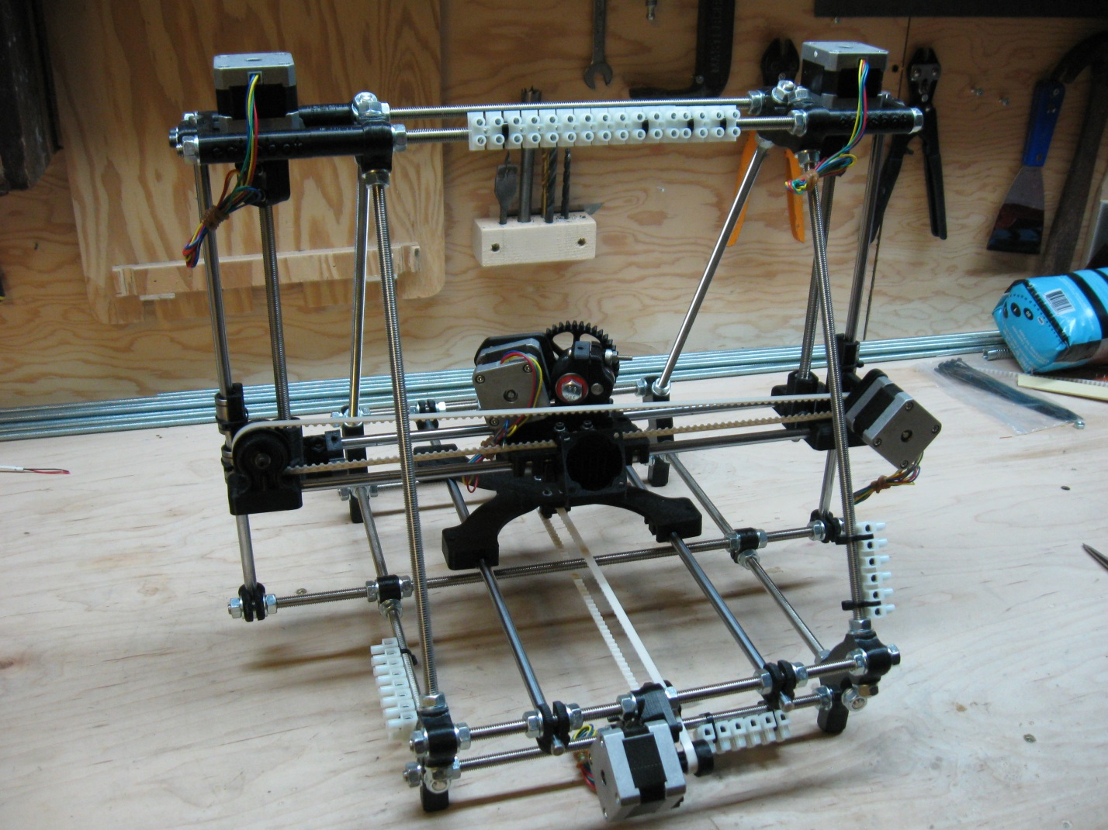

# Step 3 – Attaching the 3 axis End-Stops

(Note: need to take a picture of 3 end stop mounts with the bolts, nuts, and hex wrench

Need a new picture of the tightened Y-Endstop.

Also: some of the following pictures may need to be lightened for better viewing)

The next step is to attach the 3 end-stops for the 3 axes of the printer. For this, you will need the 3 wired and numbered micro-switches. The wires are white sheathed and numbered 2, 4, and 6 and are pictured. You will also need the 3 printed end-stop mounts, 3 holding bolts and nylock nuts (3mm bolts and nuts, also pictured). You’ll also need a 3mm hex wrench to tighten the end-stop mounts in place.

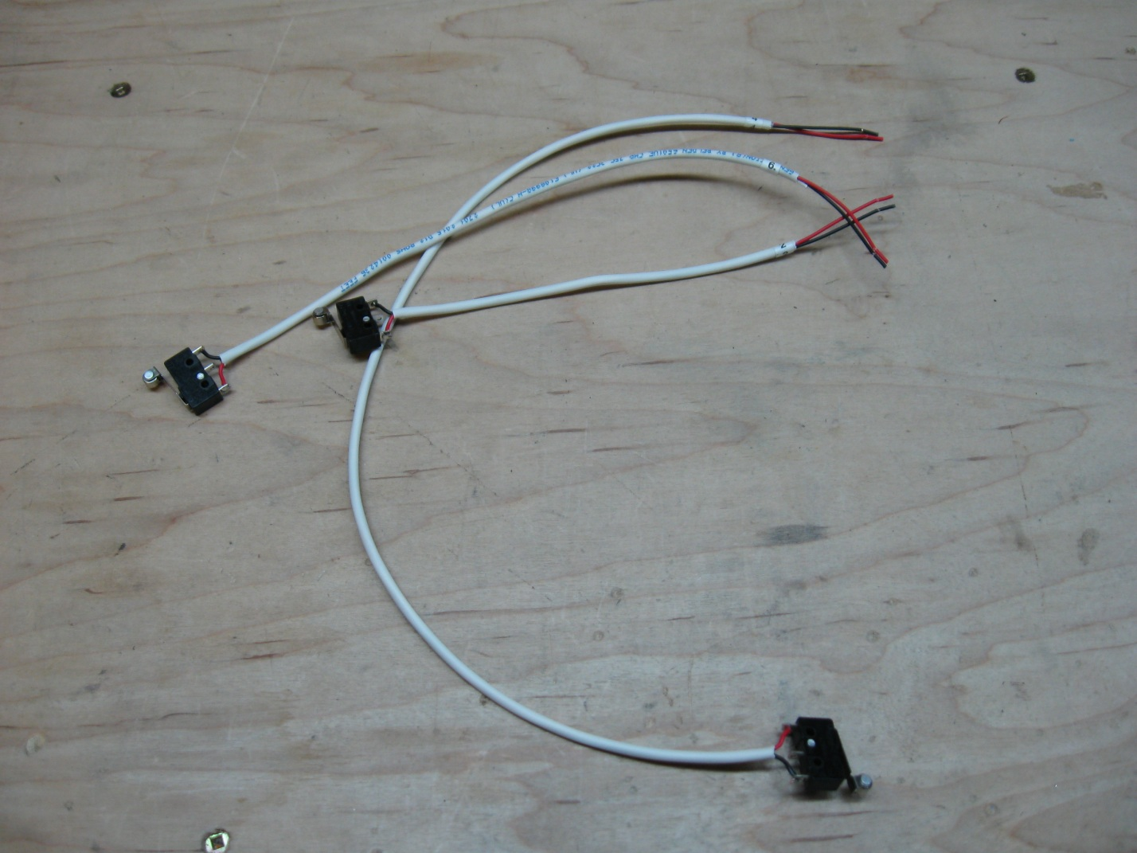

We’ll start with the X-End-Stop numbered (4). You’ll need to start by placing the wired micro-switch into the end-stop holder in the same way that it is pictured below. Notice the direction that the lever of the micro-switch is point in relation to the printed end-stop holder. The nut capture should be on the opposite side to the lever action.

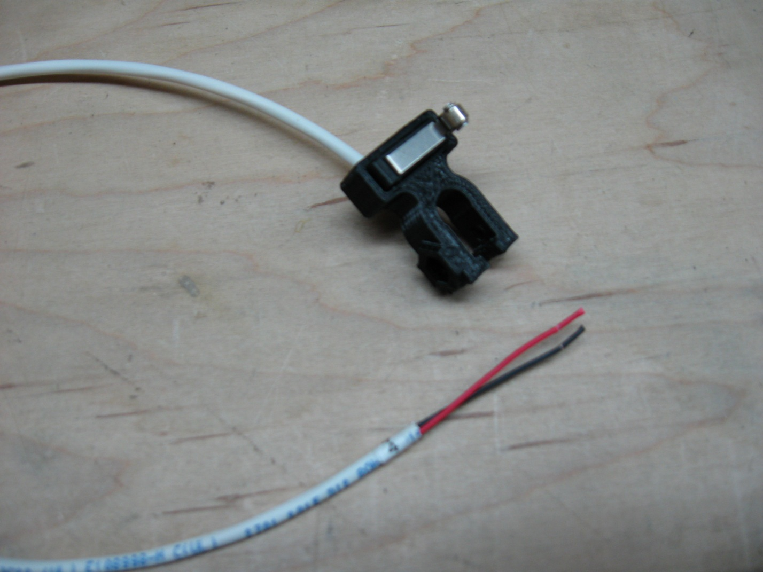

Be sure to firmly press the micro-switch into the holder so that it seats fully into the holder. Once you have the micro-switch in the holder, the combination of the two can be attached to the printer. Again we’ll be working from the back of the printer so place it on its feet, with the front pointing away from you. The printed end-stop holder is then snapped over the X smooth rod closest to you, and the bolt and nut are affixed loosely. Once it is snapped on, and the bolt and nut have been inserted, slide the mount as far right as you can, butting it right up against the X-motor mount (see picture below).

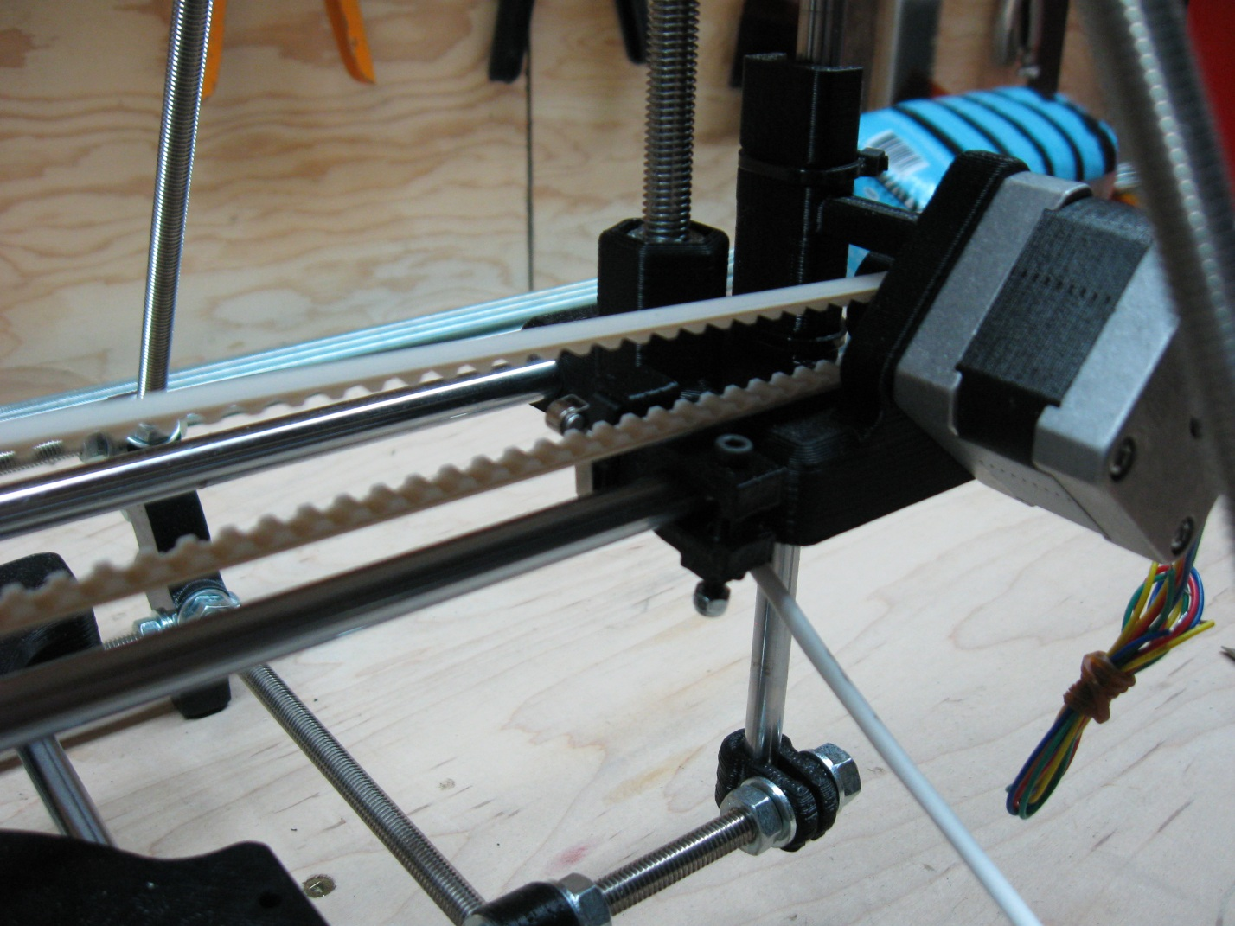

Once the end-stop is positioned in the correct spot, tighten the mounting bolt until the end-stop is difficult to move, but not so tight that the plastic begins to change color. If you tighten the mount too much, you can break the mount. The gap on the mounting block should look something like this:

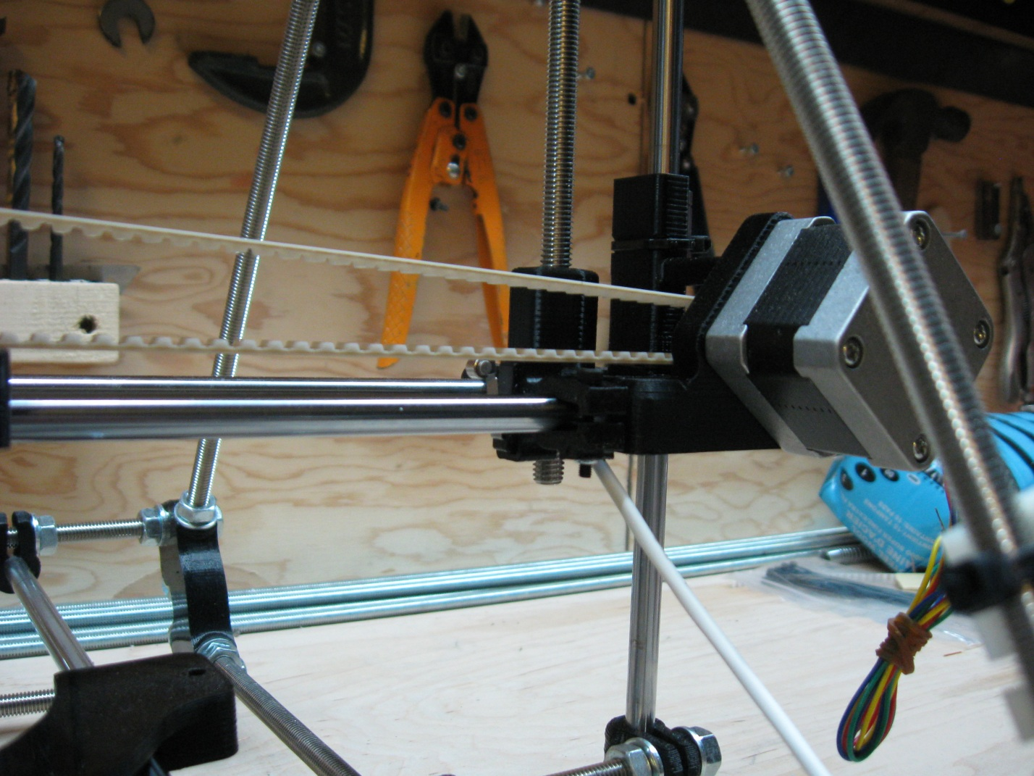

The final configuration should look like the following picture when viewed from the front of the machine.

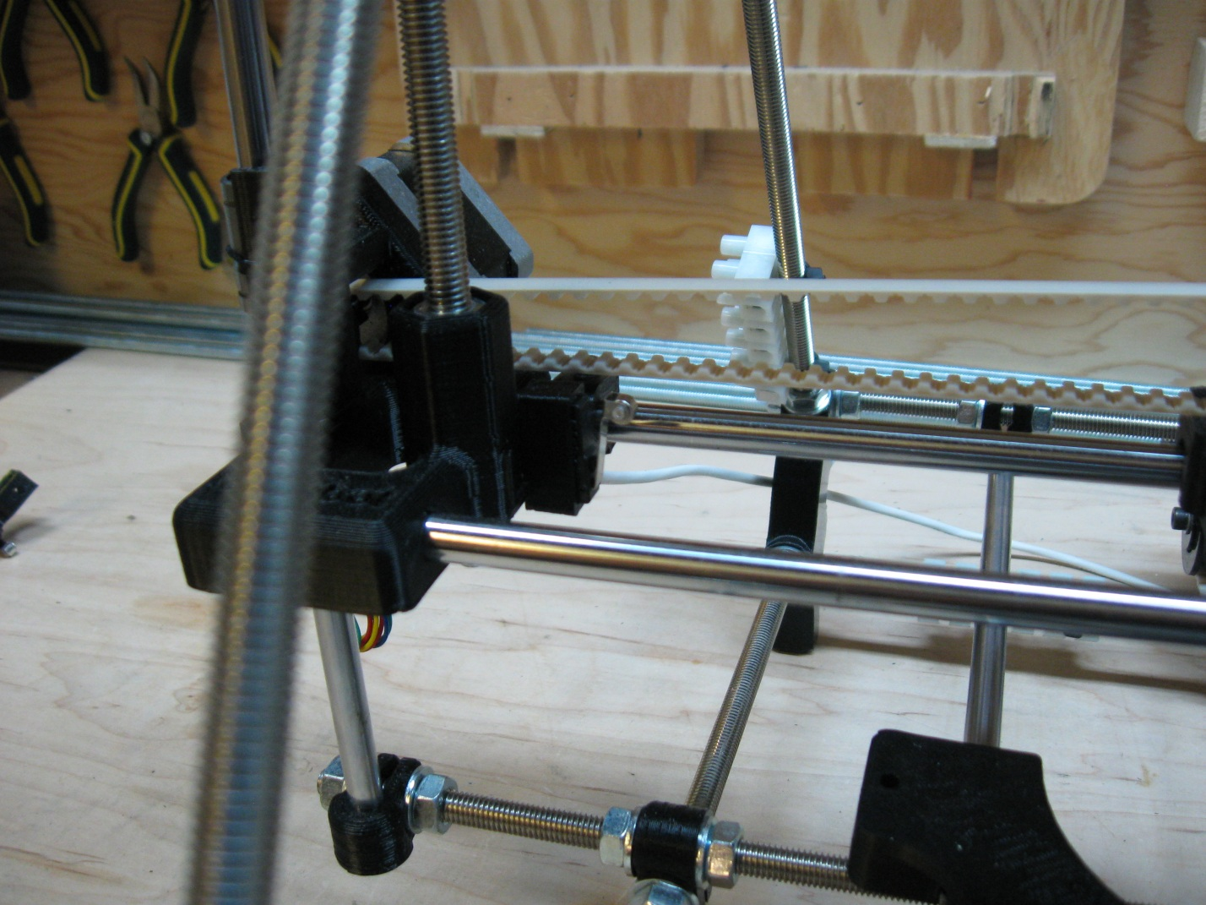

The next end-stop to be attached is the Y-Axis end-stop which will be attached to the machine from the back as well. The micro-switch used for this end-stop is numbered (2) and should be seated into a printed end-stop mount in the same way that the X end-stop was mounted, with the lever action opposite to the nut capture.

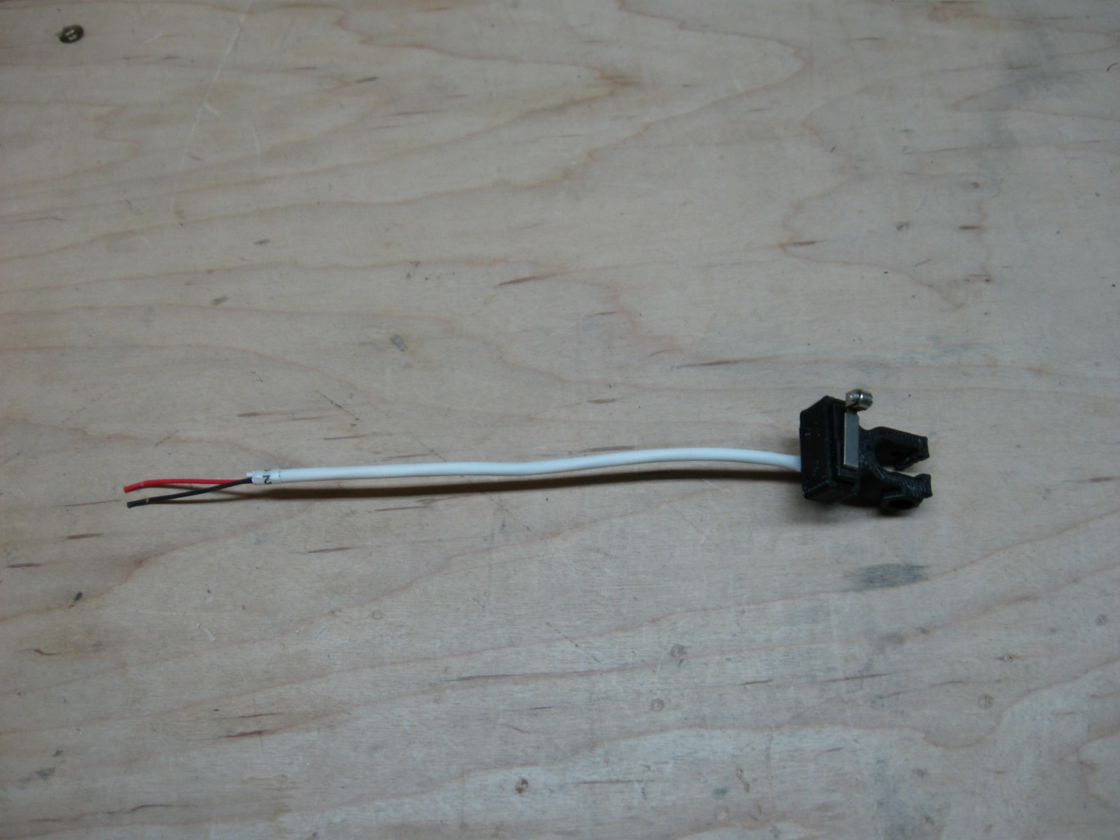

The Y-Axis end-stop is placed on the right hand Y-Axis smooth bar when the machine is viewed from the back. Snap the end-stop onto the bar as pictured, insert the bolt and attach the nylock nut. Then pull the end-stop as far back on the rod as you can.

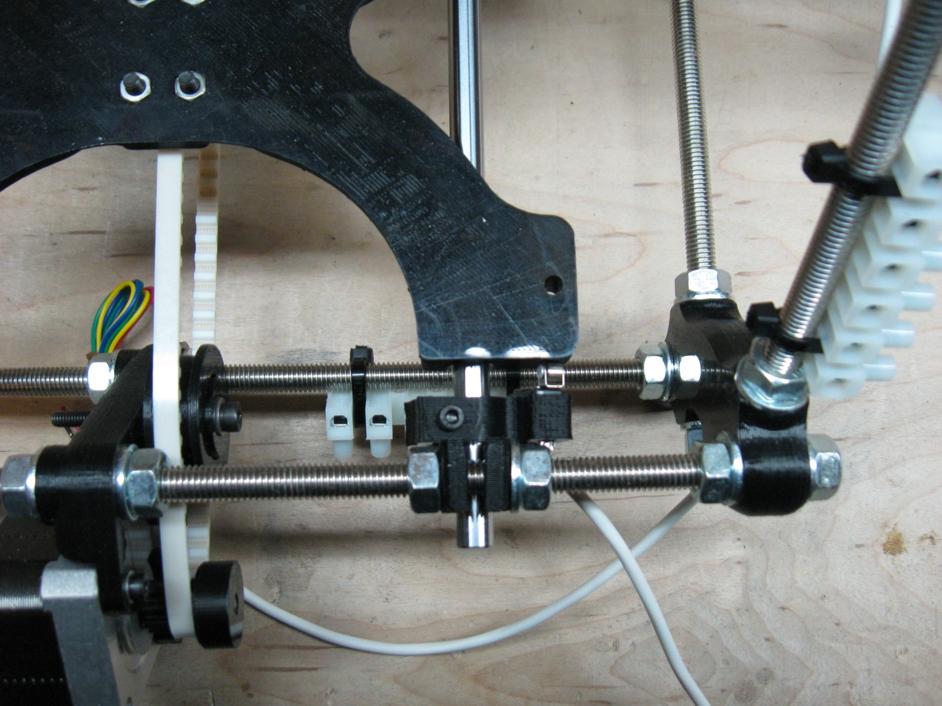

This end-stop is positioned at a slight angle to the bed so that the end of the lever will make contact with the edge of the Y-Carriage and engage the end-stop properly when the carriage is in its home position.

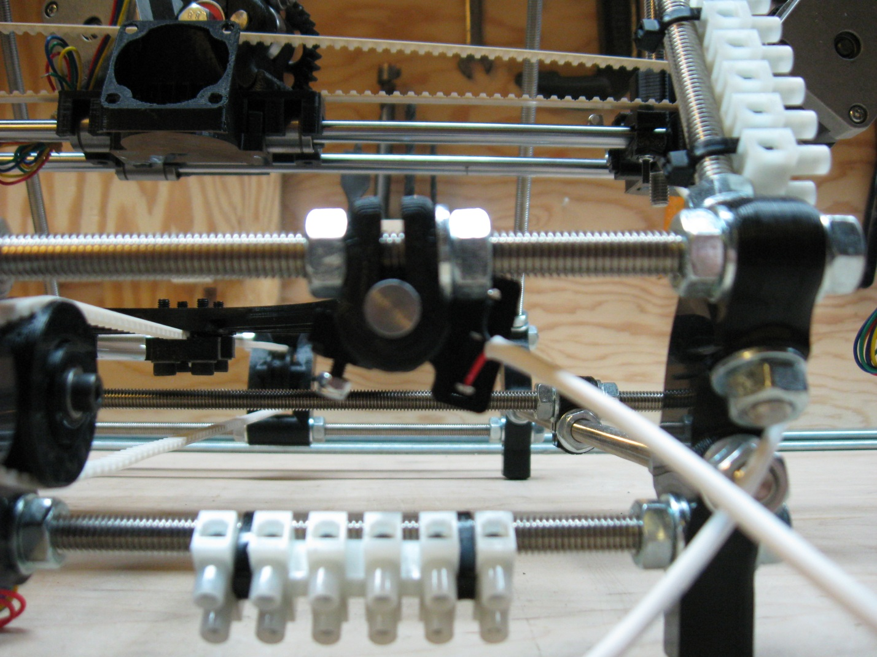

Once you are happy with the positioning of the end-stop, tighten the holding bolt until the end-stop is difficult to move but not so tight as to damage the end-stop holder.

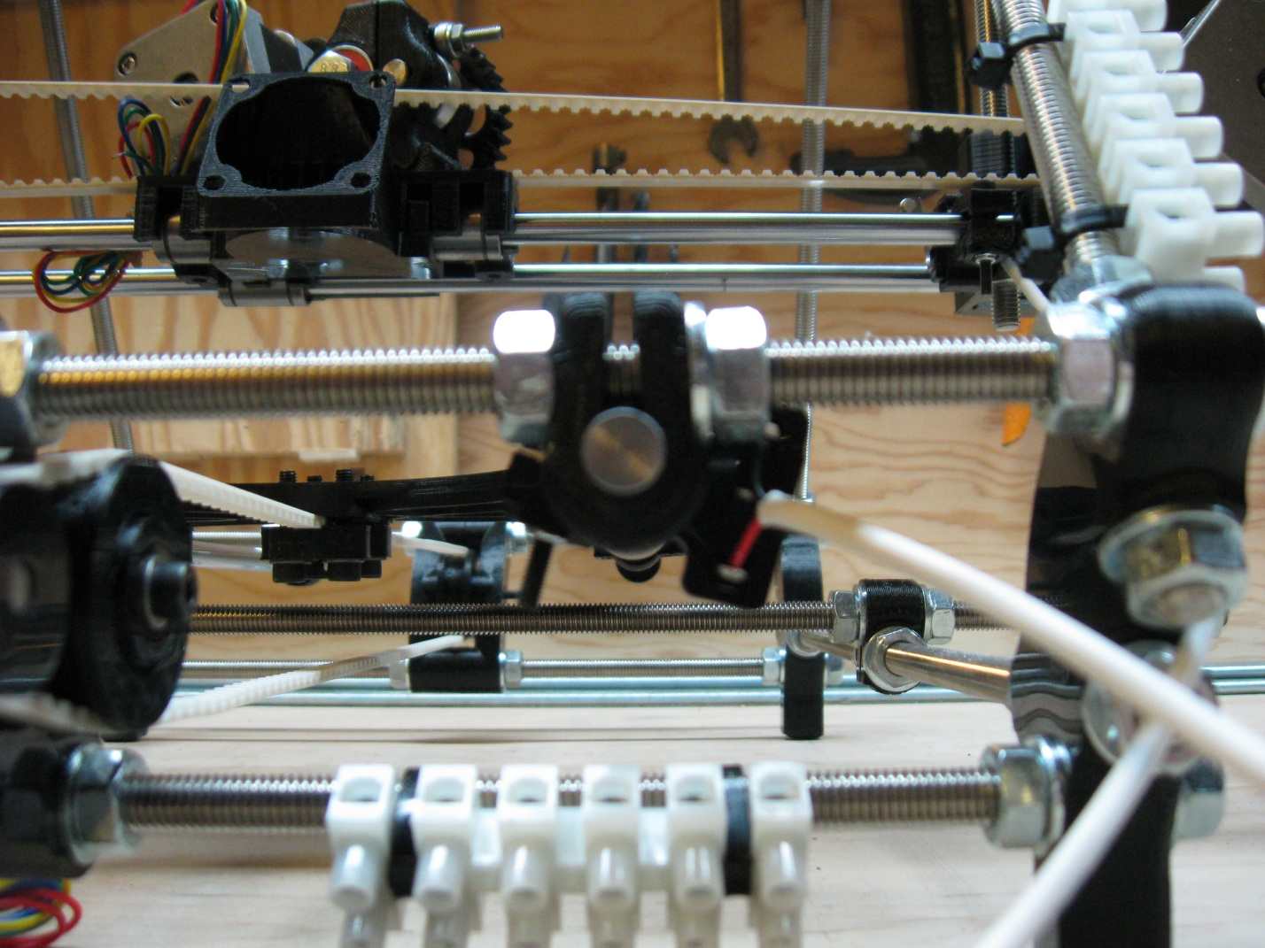

The final end-stop to be attached is the Z-Axis end-stop which will be attached to the machine from the back as well. The micro-switch used for this end-stop is numbered (6) and should be seated into a printed end-stop mount in the same way that the X end-stop was mounted, with the lever action opposite to the nut capture.

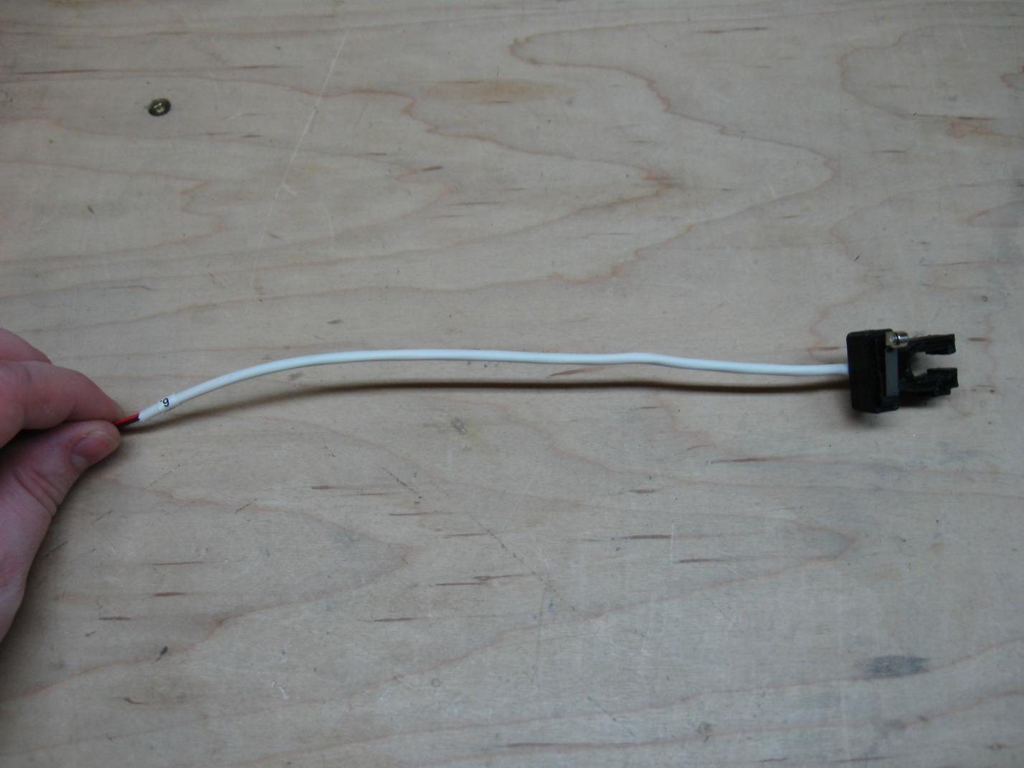

This end-stop is clamped onto the left Z-Axis smooth rod when the machine is viewed from the back. Snap the end-stop onto the smooth rod underneath the X motor mount, insert the bolt and attach the nylock nut. This will not be the final placement for the Z end-stop, but for now it can be placed near the bottom of the X-idler mount, and at an angle so that the end of the micro-switch lever does not pass through the gap in the idler block. You can then tighten the end-stop so that it is firm. But again, we will come back to this end-stop later on when we are doing our final alignment and calibration.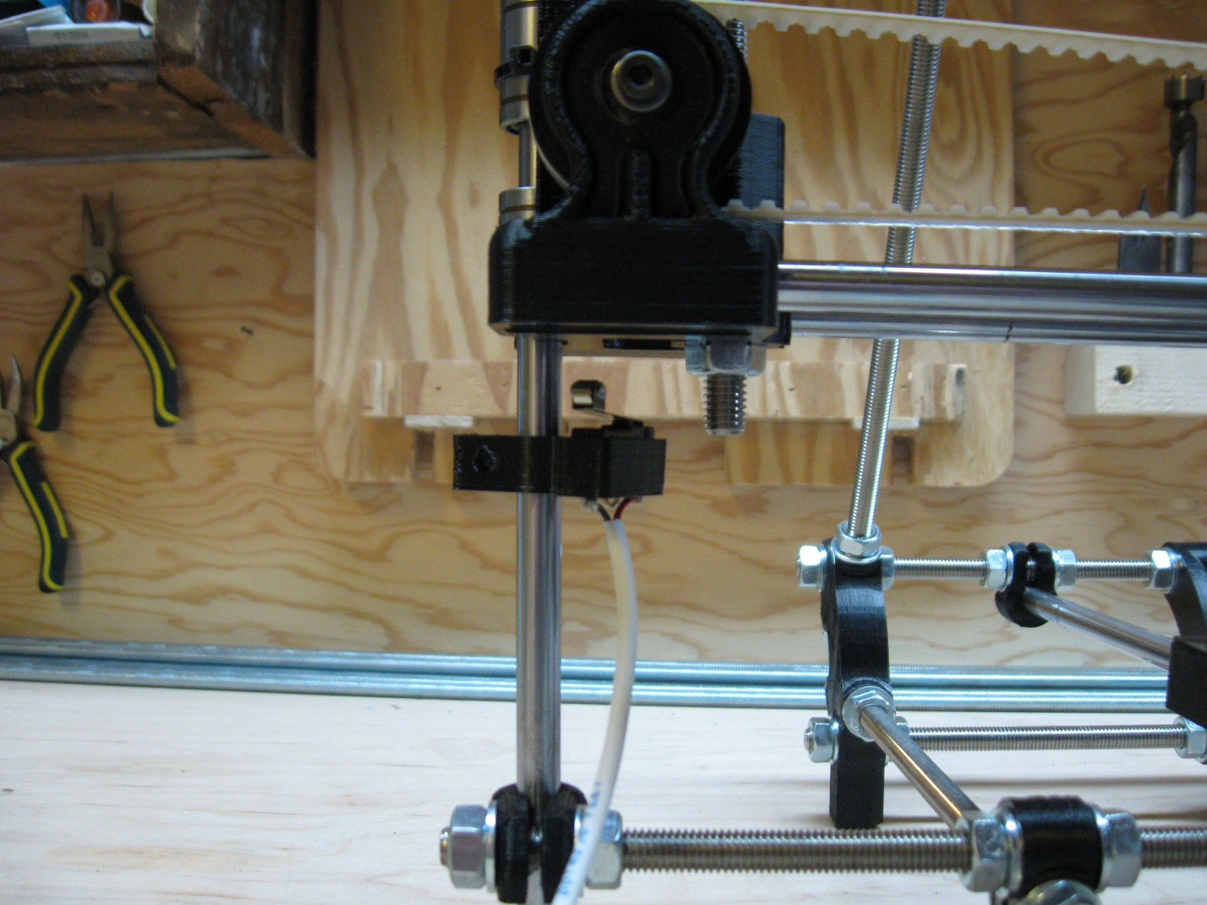

Once you are happy with the placement of the end-stops, step 3 is completed.

# Step 4 – Attaching the Heated Build Platform (HBP)

(Note: the pictures for this section and the instructions will need to be updated in the future)

To attach the Heated Build Platform, you’ll need:

1. The HBP itself
2. The HBP controller
3. A slot screw driver
4. 4mm wrench
5. 8 x 4mm nuts
6. 8 x 4mm washers

Start by placing the HBP upside down on your work surface with the array of shielded wires furthest from you. The 2 array leads are what provide power to the nichrome heating wires on the top of the HBP. These wires may be found on the right of the array, or the left depending on which HBP you get. There is no difference in the functioning of the HBP due to the wire position; it’s just a function of how the HBPs are built. The 2 center wires are the leads for the thermistor that reads the temperature from the HPB.

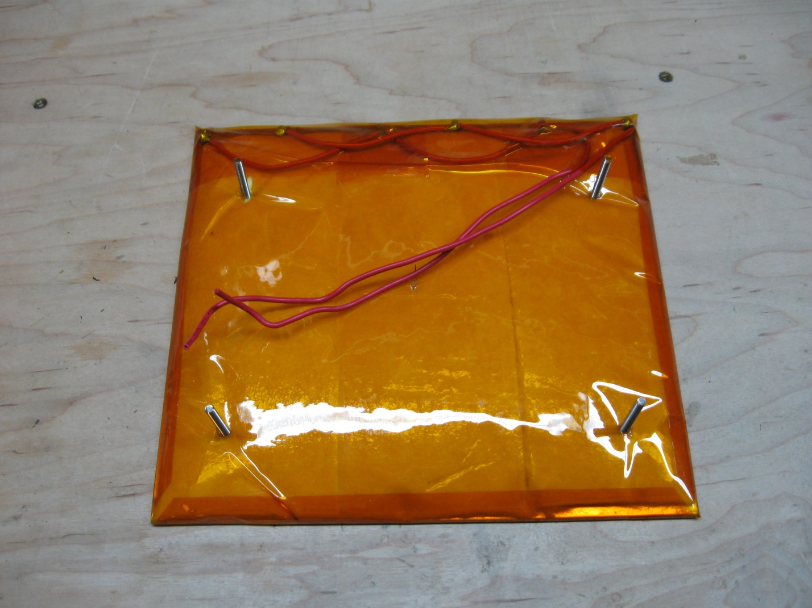

Next attach the heating wires from the array to the terminal block on the HBP controller in the positions that are labeled (B). There should be 2 (B) positions, and it doesn’t matter which of the heating leads goes which (B) position. Then attach the thermistor leads to the positions labeled (T). There should be 2 (T) positions as well, and it doesn’t matter which lead goes to which (T) position.

Picture needs to go here

Once the leads have been attached, place the HBP controlled onto the back left leg of the HBP and secure it down with 1 of the 4mm nuts. Then tape the dangling corner of the HBP controller to the bottom of the HBP as pictured below. With that complete, threaded 3 more 4mm nuts onto the 3 remaining legs to a height comparable to the position of the nut holding the controller on. They don’t need to be perfectly aligned yet, that will take place during final alignment and calibration.

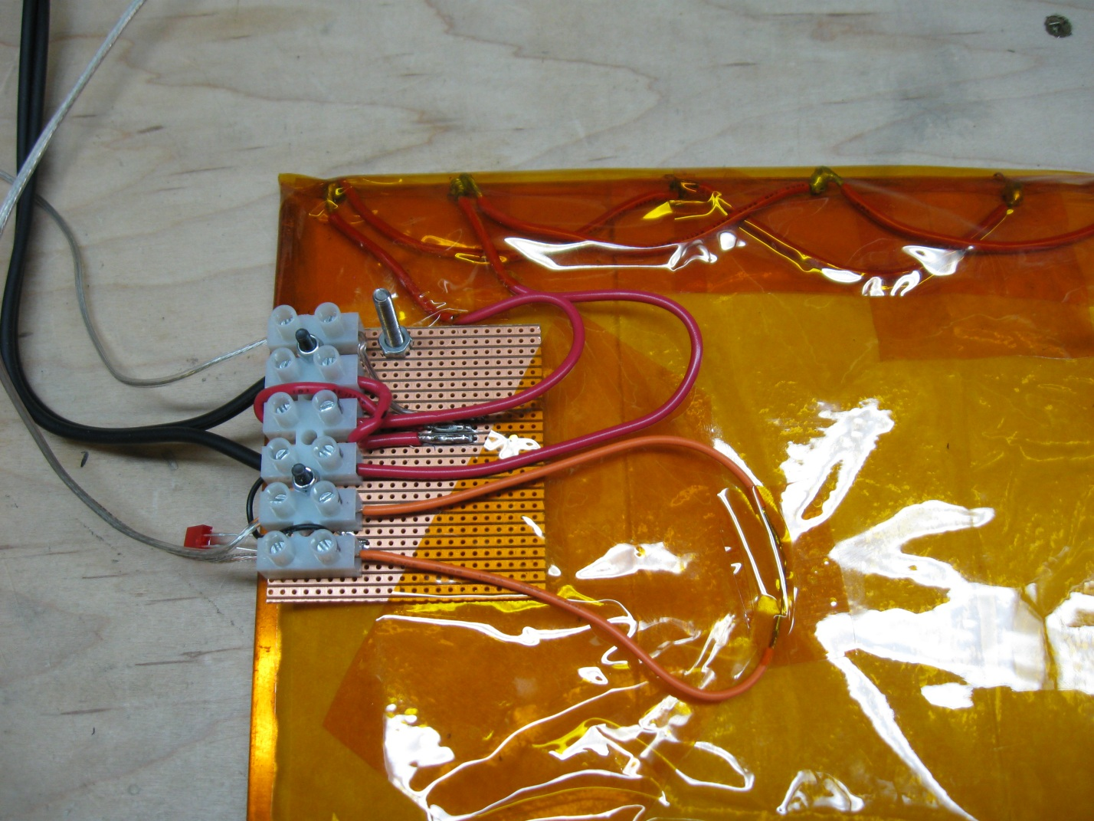

With the controller attached, and the nuts on each leg, the HBP is ready to be attached to your ecksbot. With the ecksbot positioned with its front facing towards you. Pull the Y-Carriage as far forward as you can. The 4 legs of the HBP will be attached to the 4 mounting holes in the Y-Carriage.

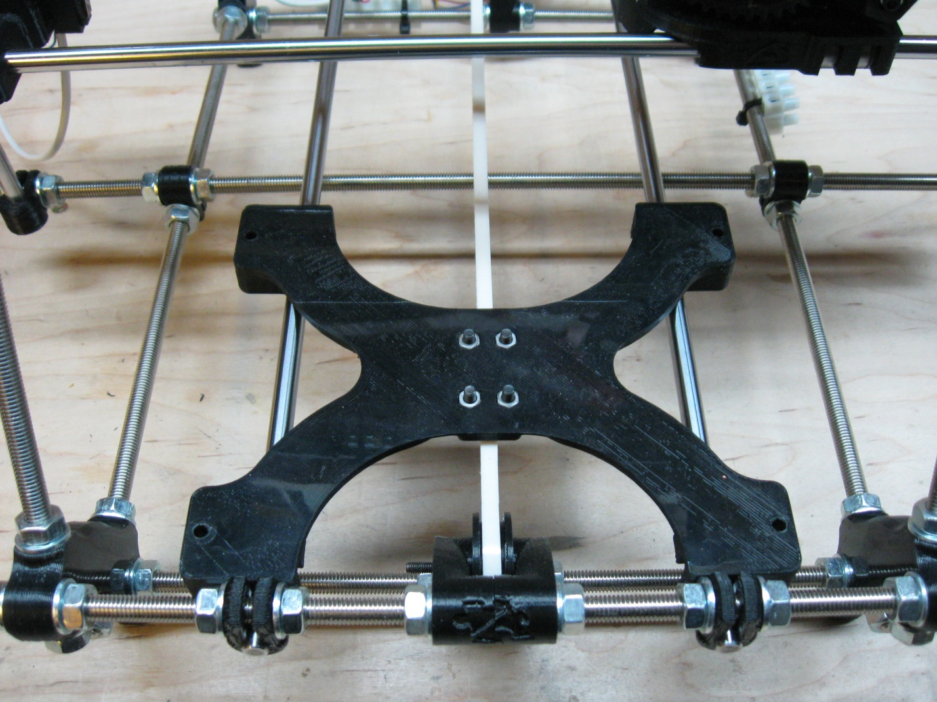

The HBP will be situated with the control block facing to the right when viewing the ecksbot from the front. Each of the 4 legs must have a 4mm washer on it before it enters the mounting hole and as you can see from the next picture, it is tight quarters, so it might take a try or two before you get each leg into its respective hole with a washer attached.

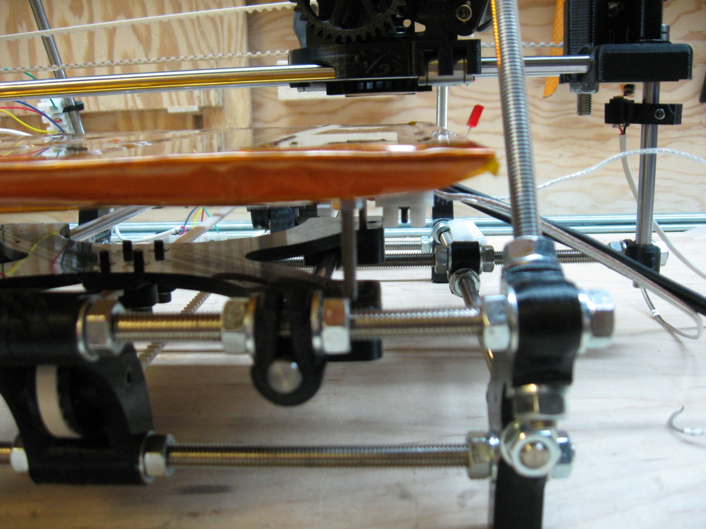

When pushing the HBP onto the carriage, be careful not to push any one side too far in comparison to the other corners as you may accidentally bend the HBP. Once the HBP is seated nicely onto the carriage, add a 4mm washer and 4mm nut to each of the leg bottoms and secure snuggly. We’ll come back to set the height properly once we are ready for the final alignment and calibration.

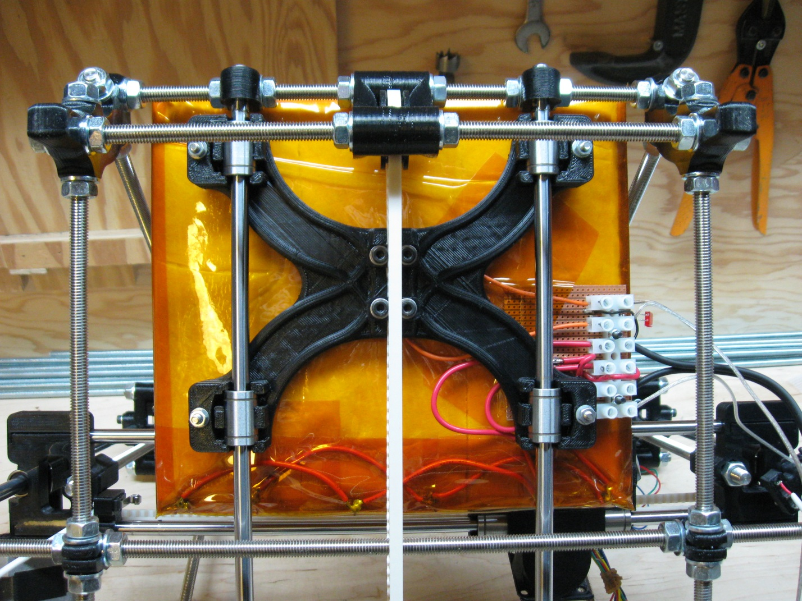

# Step 5 – Attaching the Hot End

# Step 6 – Attaching the wires Part 1

# Step 7 – attaching the wires Part 2